MONEYPEDIA
To the extent that money is a public medium it should have unaltering clarity and consistency in its definitions.
Welcome- to the 5 W’s & H:
WHAT: This site’s function is to serve as a public de-mystification (in both academic and common language) of:
a] basic monetary-economic terms,
b] their origin and how they became ‘mystified’ (mostly over the course of the 20th century),
c] while also introducing (a global-historical consistency to) core political-economic concepts
that were and/or are deemed necessary for the common good.

WHY: ‘Everyone’ these days (2020’s) seems to have their own long list of observations on how the ongoing crises (or singular ‘long crisis’) of the 21st century is challenging-- if not upending-- many 20th century institutions. Not to pick or play favorites here, it seems that what the institutional crises have in common pertains to the great millennial-era transition from the ‘2nd Industrial Revolution’ (c.1870’s-1970’s) to the often contrarian ‘3rd Industrial Revolution’ (from the 1970’s--); and this truly revolutionary transition is also concurrent with mankind having to negotiate a hitherto unprecedented environmental crisis in the Earth’s biosphere. Crises of course, are not all bad, given a long-term orientation (危机). Like it or not, ready or not, salient institutional change is upon us, as a species (negotiating its physical-trophic environment); and Monetary Economics is (increasingly) the one mystery factor that circulates, like blood, between within and through nearly all of these institutions-- making them, it is (habitually) presumed, more effective and efficient. But ‘effective & efficient’ for whom, and at what cost? Monetary and other political-economic institutions should be growing more comprehensible and accountable with the monetization phenomenon, not less.
Why wait another say twenty years or so for formal academia to essentially ‘prove what we already know’ (or something that has already long been in existence)? The Crisis (in political economy) is now, and is not being resolved with (second millennium-esque) judgement-based ‘reactions-think’ of the past. It is possible to bring clarity and coherence sooner rather than merely later, in an ethical and consistent manner.

WHERE: The bird does not stop its flight at the imaginary/abstract political boundaries that demarcate the political institutions of man; neither have the sea or wind currents that primarily distribute the things that mankind needs for basic sustenance and growth. This site’s analysis, although encompassing the world economy, is primarily from the vantage of a longterm American viewpoint and perspective, bearing in mind the American people’s traditional, constitutional, and historical charge (concerning open, accountable, and clearly-articulated public institutions).
WHEN: All of human history has been a relationship between mankind and the trophic-eco resources of the Earth’s biosphere/environment. It is not (ethically) possible to ‘start from scratch’. Today’s institutions have roots that are often very deep, if not culturally ‘sacred’. From a historian’s perspective, getting one’s head around the interplay of institutions requires a lot of digging and a consistent application of ‘5 Ws & H’ type questioning, in addition to open-mindedness to the (common sense) demands of changing evidence.
HOW: A world of increasing institutional complexity is a world with more puzzle pieces. This does not have to be overwhelming; it can also be edifying, given the discipline of intellectual consistency and coherent organization. One doesn’t have to be ‘Shakespeare’ to take liberties with the (built for liberality) English language and information age capabilities of word processing, formatting, and color. Tools are made to help us.
& WHO: ‘Your 3rd Estate’ EDITORS, and primary CONTRIBUTORS:

Michael White
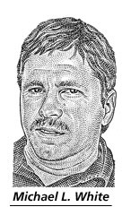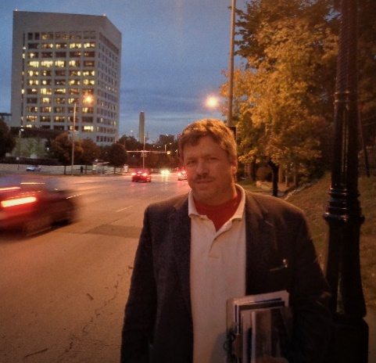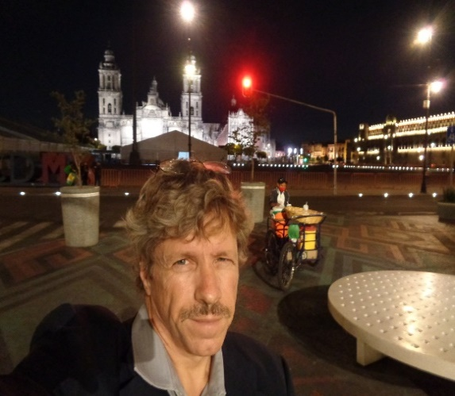
Michael White (in addition to being internationally-vetted: https://www.peoples.ru/state/teacher/?page=10)
has taught many subject levels (from undergraduate business studies and English to history and
cultural communication), living and working on 4 continents and visiting approximately 100 countries.
A thirteenth generation American and 3rd generation educator, White grew up in a university
‘History family’ and has held life-long determinative research interests (pertaining mostly to truths-myths and/or different cultures). Sample writings, sometimes collaborative, may be viewed at: http://www.nationalityinworldhistory.net , and www.nationalityinworldhistory.net/LanguageandCulture.html . His monetary-focus within empirical political economy began with the Financial Crisis of 2008-09,
while a doctoral candidate in World History at Wuhan University. Subsequent participation at the
2014-2019 American Monetary Institute conferences in Chicago followed suit.
White still travels widely and resides in (the multiethnicity of) Austin, Texas.

Allen Smith
Allen Smith taught “Money and Banking” at the Henry George School in New York City for a decade, and has long been an independent-minded reader in political economy classics. A sometimes monetary conference participant, his formal background is in computer programming languages.
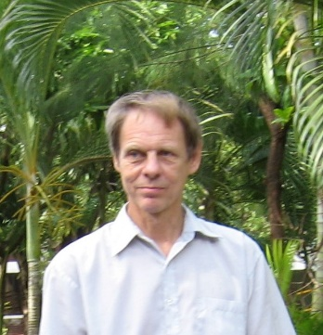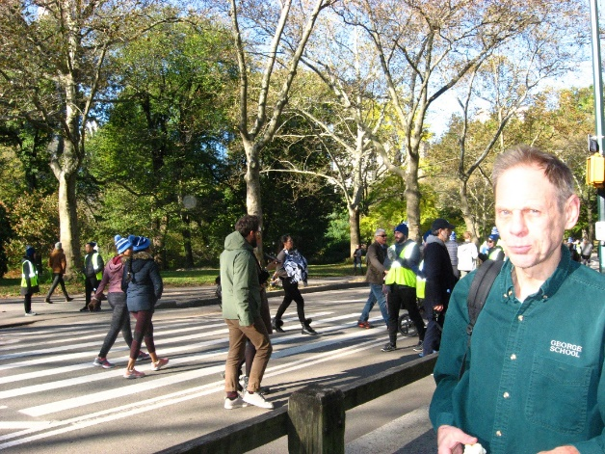
Smith resides in Manhattan, New York City.

Dennis Kenaga
Dennis Kenaga is a retired computer programmer with the Michigan Department of Transportation, linguo-biblical scholar, and member of Grace Orthodox Presbyterian Church.
From 2014-2019 he attended the three-day American Monetary Institute conferences and is active at the local, state, national, and international levels of political economy and politics.

Kenaga resides in Lansing, Michigan.

Randy Cook
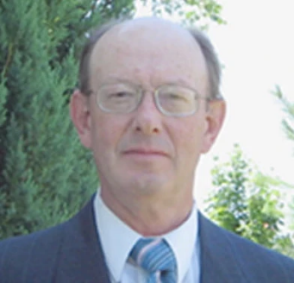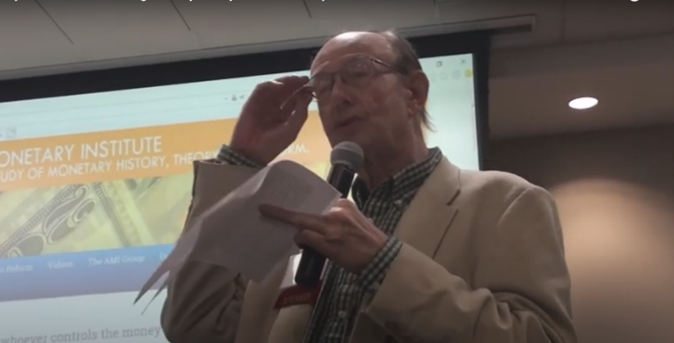
Randy Cook was elected President of the National Organization for Raw Materials (NORM) in 1997. NORM was formed in 1936 to analyze the economic heritage and record of the USA.
Results from that continuing research demonstrate the viability of a “Par-economy” approach
as a sound strategy for national prosperity-security for current and future generations. Cook
has authored numerous issues of NORM’s Economic Report of the Producers, concerning primary sector-based economic practices & policies, the “American System” of economics, and humanely practical solutions for local, national, and world conditions.
Cook resides on his blueberry farm outside of Charlotte, Michigan.

Geraldine Perry
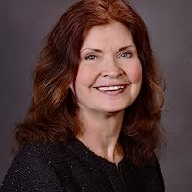 https://www.geraldineperry.com ; https://thetwofacesofmoney.com
Geraldine Perry is an award-winning author from Orland Park, Illinois, whose environmental writing is academic, yet approachable. Her books and articles have tended to focus on long-term solutions for economic, health, and environmental issues. She is also active with local farmers who supply her locally engaged food community with some of the best nutrient-dense food on the planet.
Perry resides in the southwest Chicago suburbs.

Howard Marks
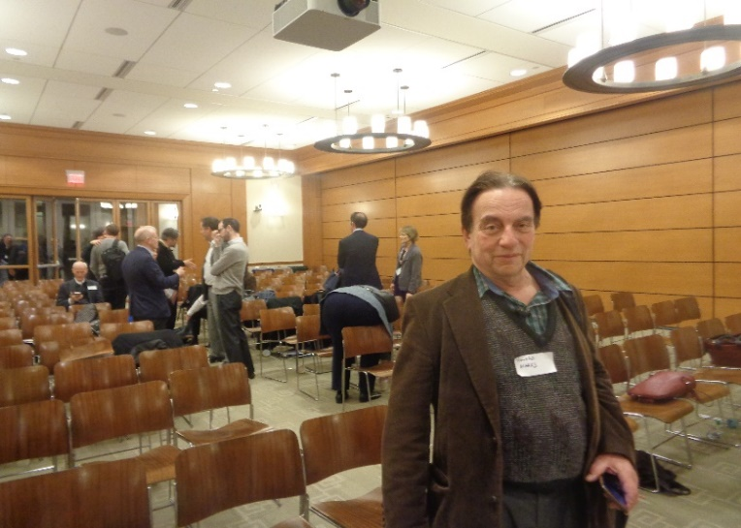
Physicist, electronics consultant, and export-import entereprenneur Howard Marks has worked in non-profits for senior citizens, grant-writing, and other consulting. He is a founding member for the Alliance for Just Money (2017) and an American Monetary Institue associate since 2007.
Marks resides in greater Chicagoland.

frequent CONTRIBUTORS to this work-in-progress include:
- from over the past-century or so (helpful material has been sourced from):
Steve Keen, Catherine Austin Fitts, Michael Hudson, Joseph Huber, Perry Mehrling, Edgar Wortmann, Michael Kumhof, Richard Werner; Carroll Quigley, Herman Daly, Thorstein Veblen & Frederick Soddy (the great critics), and Simon Kuznets & Benjamin Graham (the great synthesizers).
- from further back (mostly chronological order):
Aristotle (middle class), 重农主义 (physiocracy), Thomas Aquinas (moral pricing), ‘Spinoza-De Bono’ (‘modern’-‘design’-think), Montesquieu (empirical social science), ‘Smith-Bentham’ (imperial-usury), Thomas Jefferson (Americana), Alexander Del Mar (the great critic), Henry George (great simplifier).
In summary...
“The people is a beast of muddy brain
That knows not its own force and therefore stands
Loaded with wood and stone; the powerless hands
Of a mere child guide it with bit and rein.
One kick would be enough to break the chain….”
- Tomasso Campanella, “The People”, early 17th century
4 Centuries Later, in the early 21st century…
Most people’s lives are dominated by money & monetary institutions, but they do not even know what money, currency, and monetary institutions are-- a very dangerous situation for any republic-- yet alone a Republic with democratic pretentions (in our Information Age-to-Knowledge Age transitional era).
REFERENCES (suggested shortlist [chronological]):
- https://archive.org/details/in.ernet.dli.2015.84331/page/n7/mode/2up?q=world+commodities [Graham, 1944]
- https://www.economy101.net/Contents.html [Lundgren, 1994]
- https://www.ineteconomics.org/research/experts/pmehrling [(contemporary) “Money and Banking” (Mehrling, 2015-23)] ; https://www.youtube.com/watch?v=sR1pimFztPk [Mehrling endorsed without qualification by Bank for International Settlement]
We welcome serious reader Comment (public) & Queries (private):
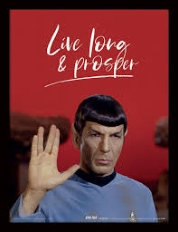
private Feedback and public Comment

A sub-domain and/or complementary “wiki”-style website, moneypedia.US , is under construction, like a smaller wheel (that money-currency is) within the larger wheel of political economy. For the time being, this singular site, politicaleconomy.help serves as the work-in-progress.
See also: nationalityinworldhistory.net
https://www.nationalityinworldhistory.net/LanguageandCulture.html
White initiated collaboration with (fellow AMI participants) Kenaga from the winter of 2015-16, and Smith and Marks in 2018, in addition to briefly meeting Cook and Perry (being invited to their weekly discussion group) in 2019-20.
For example: https://www.youtube.com/watch?v=rKJfqW7S4yI
Although there are, of course, too many contributors to mention here (in addition to the comprehensive Sources list), Editors would also like to acknowledge the contributions and initiative of Stephen Zarlenga (and his successors Bob Poteat, Jamie Walton, and Steven Walsh) in hosting the annual AMI conferences for the general public, as well as Christine Desan and Morgan Ricks’ hosting of the Just Money conferences at the Harvard Law School in 2018 and 2023. James McAndrews and Lev Menand have also provided key intell on contemporary regulation of money & currency, while Perry Mehrling, Robert McCauley, and Joseph Wang have been revealing the (past half-century’s) whale-in-the-living room of “eurodollars”. The puzzle simply does not work without these pieces.
https://aeon.co/essays/at-a-time-of-zealotry-spinoza-matters-more-than-ever (1632-1677; a.k.a ‘freedom of thought’) https://www.debonogroup.com/edward-de-bono (1933-2021; a.k.a. ‘design-thinking’)

